3/22/2025

Riphah International University

Lab: 06

COAL

**Name:** Ayesha Tayyaba

**Sapid:** 56546

**Department:** CS

**Task: 02**

**Source Code:**

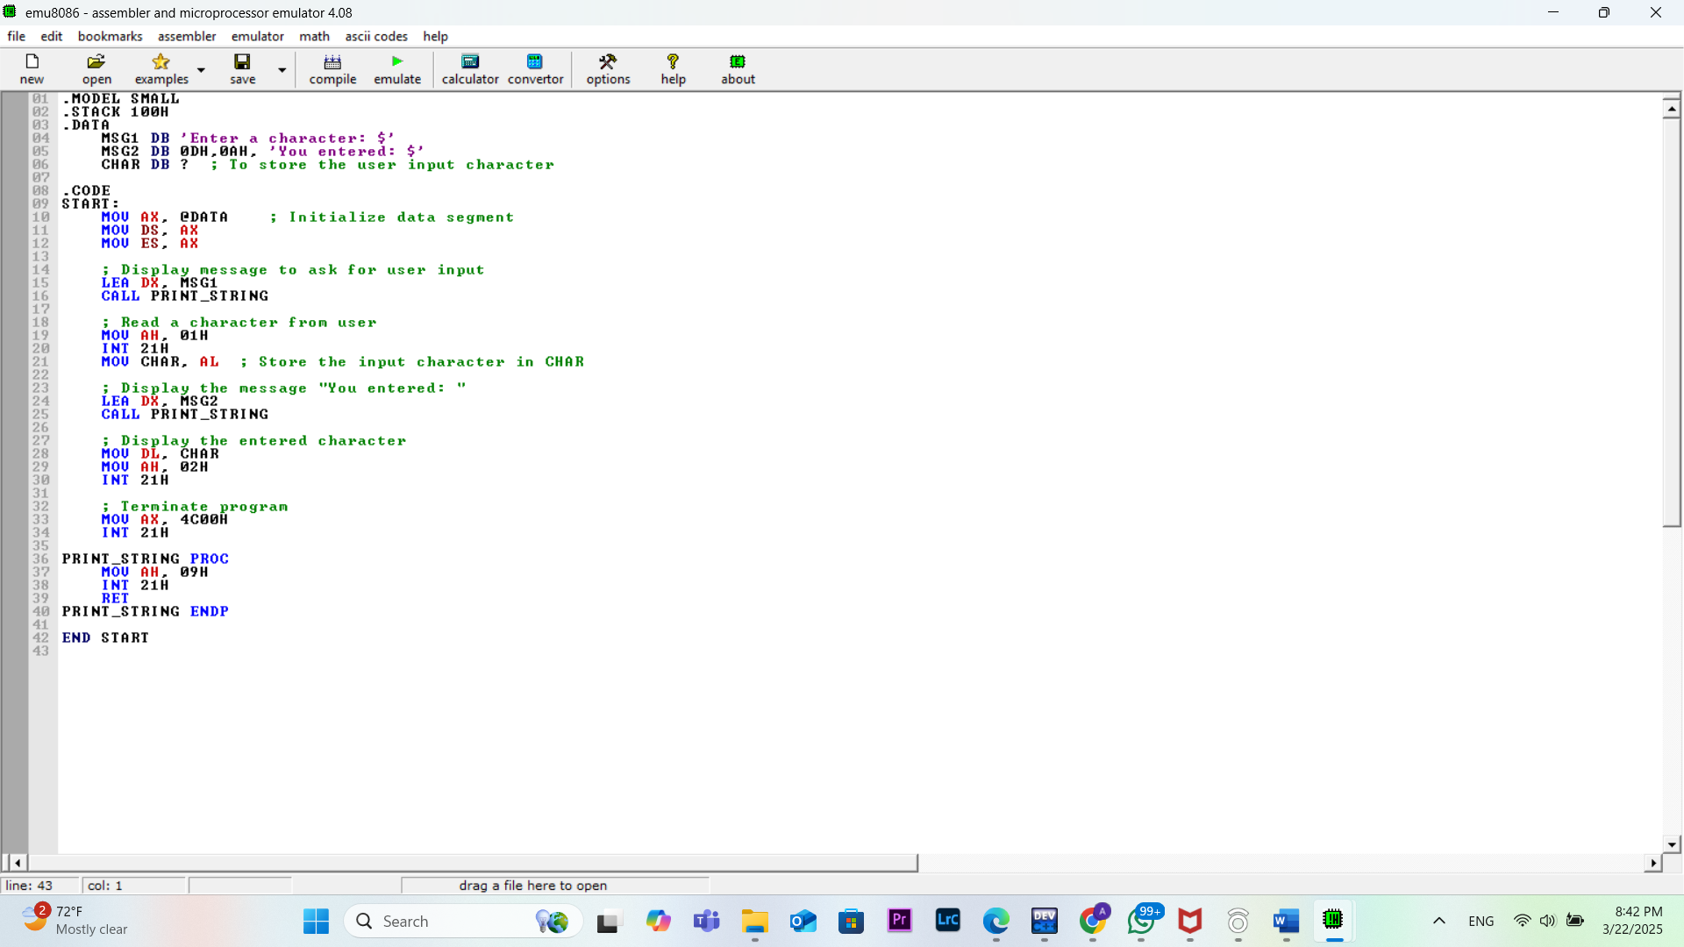

**OUTPUT:**

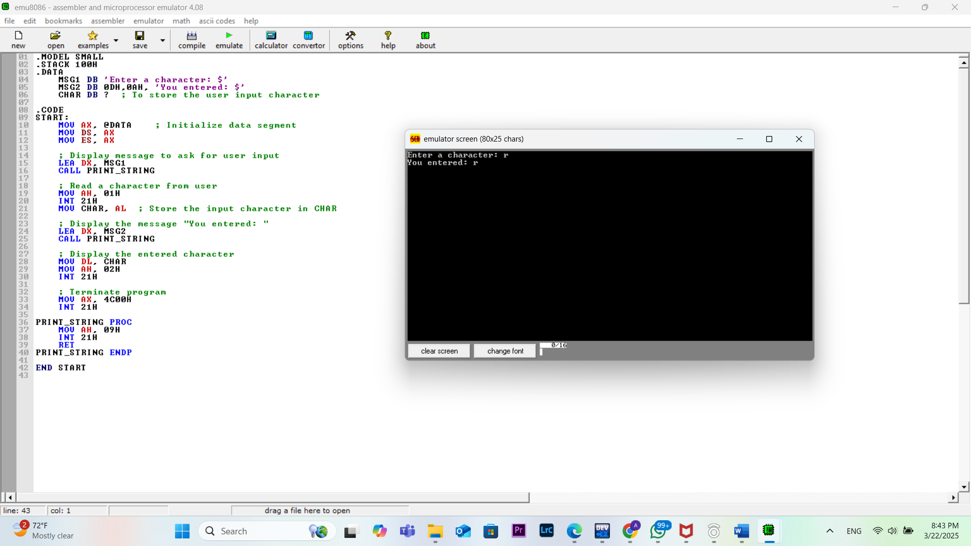

**TASK: 03**

**Source code:**

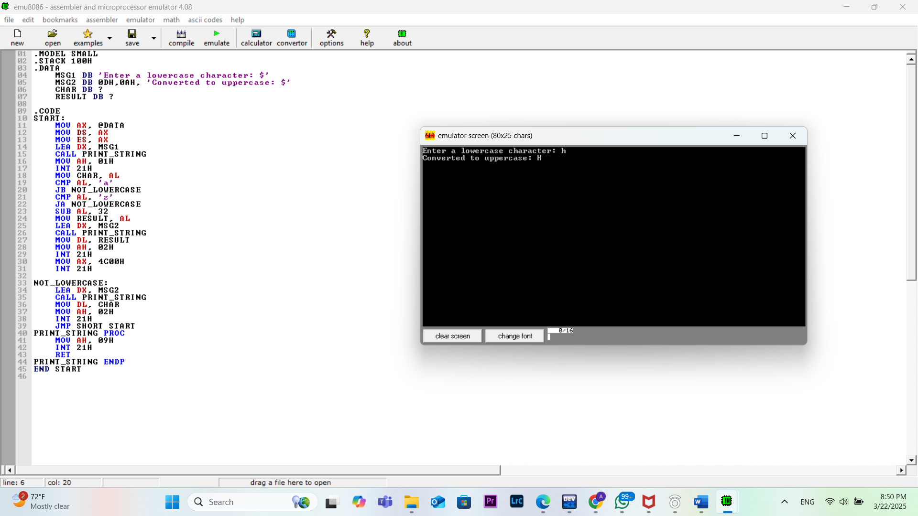

**OUTPUT:**

**Task: 01**

